Joshua Phillip – EECS 3311 – Lab3 Report – 207961907
Prism: jep4444

I hereby declare that the work done in this lab is my own work and is not a duplicate of anyone else’s work.
For me, the hardest part of the lab was filtering through the documentation and deciphering what we were supposed to do in the lab. I also had some trouble with the ETF GUI in Windows crashing due to use of void leading me to abandon void in my design(these problems did not persist when testing on CentOS but since I did most of my work on Windows, it seemed easier to develop a design that worked there). As for time spent on the lab, I lost track but likely 10+ between all the different parts, debugging, testing, etc.
A side note, I included the Person contract on top of Registry because I wanted to include the invariants that dictated what constitues a valid person in my design. The pre-conditions of the various methods in Registry are there to ensure correctness of the person invariants. I realise this puts my report at 4 pages, you can ignore the additon if you wish.

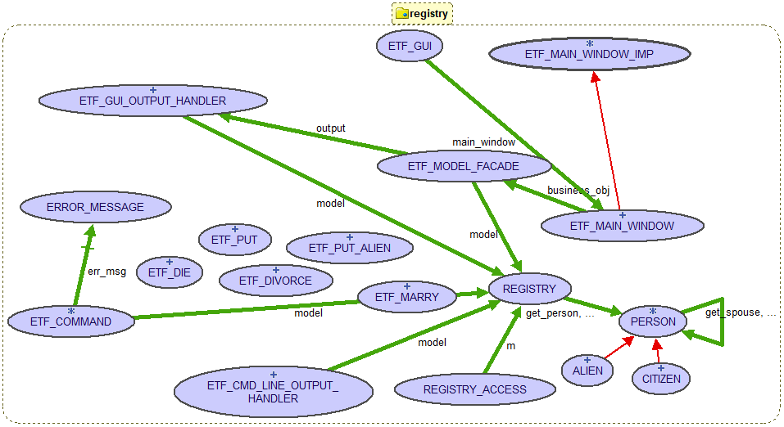
If we wanted to extend the business logic to allow for various types of non-citizens, we could add a feature to the Alien class that deals with citizenship status. From there we could add that field to the constructor to list one of the options (visitor, landed immigrant, refugee, etc.). Better yet, Alien could be made deferred and we could have subclasses for each that inherit from Alien and add the additional features in their own constructors.
class interface
REGISTRY
create {REGISTRY_ACCESS}
make
feature -- model operations
reset
-- Reset model state.
feature -- Model Commands
put (id: INTEGER_64; name: STRING_8; dob: TUPLE [d: INTEGER_64; m: INTEGER_64; y: INTEGER_64])
--adds a citizen to the registry
require
err_id_nonpositive: id > 0
err_id_taken: not valid_id (id)
err_name_start: (not name.is_empty) and then name [1].is_alpha
err_invalid_date: is_valid_date (dob.d, dob.m, dob.y)
ensure
correct_size: persons.count = (old persons.count + 1)
new_key_inserted: persons.has_key (id) /= old persons.has (id)
put_alien (id: INTEGER_64; name: STRING_8;
dob: TUPLE [d: INTEGER_64; m: INTEGER_64; y: INTEGER_64]; country: STRING_8)
--adds a non-citizen to the registry
require
err_id_nonpositive: id > 0
err_id_taken: not valid_id (id)
err_name_start: (not name.is_empty) and then name [1].is_alpha
err_invalid_date: is_valid_date (dob.d, dob.m, dob.y)
err_country_start: (not country.is_empty) and then country [1].is_alpha
ensure
correct_size: persons.count = (old persons.count + 1)
new_key_inserted: persons.has_key (id) /= old persons.has_key (id)
marry (id1, id2: INTEGER_64; date: TUPLE [d: INTEGER_64; m: INTEGER_64; y: INTEGER_64])
--marries two people in the registry
require
err_id_same: id1 /= id2
err_id_nonpositive: id1 > 0 and then id2 > 0
err_invalid_date: is_valid_date (date.d, date.m, date.y)
err_id_unused: valid_id (id1) and then valid_id (id2)
err_marry: not (get_person (id1).is_married or else
get_person(id2).is_married)
err_dead: get_person (id1).is_alive and then get_person (id2).is_alive
err_under_18: (get_person (id1).get_married_age (date) > 17) and then
(get_person (id2).get_married_age (date) > 17)
ensure
spouse1_is_person2: get_person (id1).get_spouse = get_person (id2)
spouse2_is_person1: get_person (id2).get_spouse = get_person (id1)
divorce (id1, id2: INTEGER_64)
--divorces two people in the registry
require
err_id_same: id1 /= id2
err_id_nonpositive: id1 > 0 and then id2 > 0
err_id_unused: valid_id (id1) and then valid_id (id2)
err_divorce: get_person (id1).get_spouse = get_person (id2) and then
get_person (id2).get_spouse = get_person (id1)
ensure
person1_is_single: get_person (id1).get_spouse = get_person (id1)
person2_is_single: get_person (id2).get_spouse = get_person (id2)
die (id: INTEGER_64)
--sets a person in the registry to deceased
require
err_id_nonpositive: id > 0
err_id_unused: valid_id (id)
err_dead_already: get_person (id).is_alive
ensure
not_alive: not get_person (id).is_alive
spouse_not_married: not (old get_person (id)).get_spouse.is_married
set_err_message (s: STRING_8)
--sets the error message
feature -- Model Queries
get_list: SORTED_TWO_WAY_LIST [PERSON]
--returns the registry as a sorted list
ensure
sizes_match: persons.count = Result.count
registry_unchanged: persons ~ old persons
is_valid_date (date: TUPLE [d: INTEGER_64; m: INTEGER_64; y: INTEGER_64]): BOOLEAN
--checks whether a date as a tuple is valid
get_person (id: INTEGER_64): PERSON
--checks,given an id, that the person is attached and returns the person
ensure
person_unchanged: persons.at (id) ~ old persons.at (id)
valid_id (id: INTEGER_64): BOOLEAN
--checks if the id is in the registry
ensure
person_unchanged: persons.at (id) ~ old persons.at (id)
feature -- queries
out: STRING_8
--sets the output for ETF
invariant
persons.count >= 0
end -- class REGISTRYdeferred class interface
PERSON
feature -- queries
get_id: INTEGER_32
--returns the ID of the person
get_name: STRING_8
--returns the name of the person
get_country: STRING_8
--returns the nationality of the person
date_to_string (date: TUPLE [d: INTEGER_64; m: INTEGER_64; y: INTEGER_64]): STRING_8
--converts a date as a tuple to a string
get_dob: STRING_8
-- returns the birthday of the perspn
get_married_since: STRING_8
--returns the wedding date of the person (returns 00-00-0000 for unmarried)
get_spouse: PERSON
--returns the spouse of the person (returns self if unmarried)
is_married: BOOLEAN
--returns the marriage status of the person
is_alive: BOOLEAN
--returns whether the person is alive
get_married_age (date: TUPLE [d: INTEGER_64; m: INTEGER_64; y: INTEGER_64]): INTEGER_64
--returns age at date of marriage(returns a negative value if unmarried)
is_less alias "<" (other: like Current): BOOLEAN
--used to sort users, first by name, then by id
feature --commands
set_married (p: PERSON; date: TUPLE [d: INTEGER_64; m: INTEGER_64; y: INTEGER_64])
--sets the persons spouse and date of marriage
set_divorced
--sets the person to single and sets marriage date to 0000-00-00
set_death
--sets the person to deceased
invariant
spouse_is_alive: Current.get_spouse.is_alive = Current.is_alive
married_person_is_alive: Current.is_married = Current.is_alive or else not Current.is_married
married_person_over_18: Current.is_married = (Current.get_married_age (married_since) >= 18)
positive_id: Current.get_id > 0
valid_name: not (Current.get_name.is_empty) and then name [1].is_alpha
valid_country: not (Current.get_country.is_empty) and then name [1].is_alpha
end -- class PERSON

